Contents

Adding Sage 300 customizations to Sage 300c Web 2

Configure IP Address 2

Upload files to Sage 300c 5

# Adding Sage 300 customizations to Sage 300c Web

## Configure IP Address

1. Open the folder “Package”:



1. The “Package” folder contains the following sub folders and files.



1. **Copy** the folder “Sage300CustomizationScreens” to your **Desktop**.
2. **Run** GenerateFiles.exe as **Administrator**.

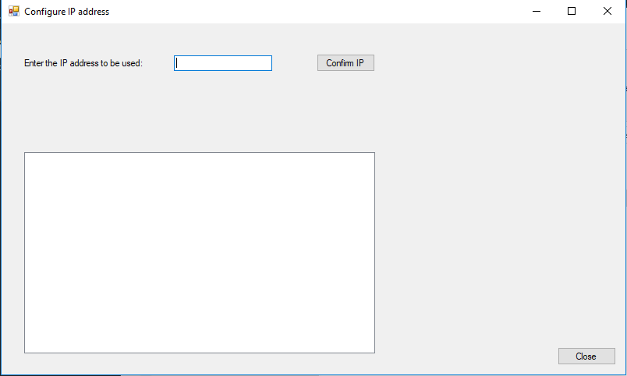

1. **Enter** your IP address in the circled textbox and **click** the “Confirm IP” button.

This function does not validate for a valid IP address. It merely captures the IP address provided.

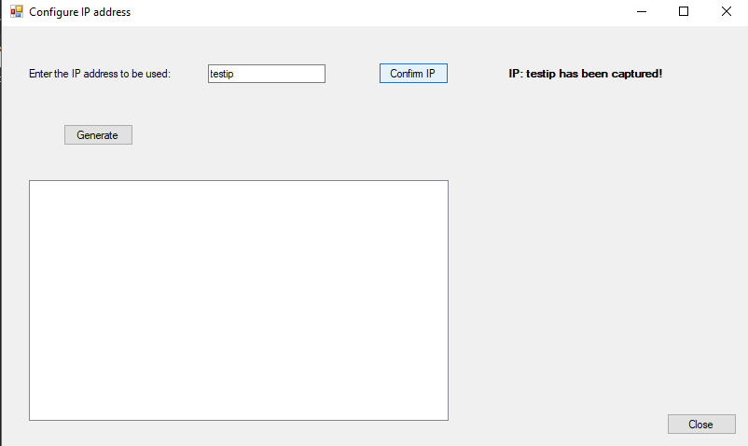

1. You will get a notification indicating that the IP has been captured.

A button named “Generate” will then be displayed. **Click** “Generate”.

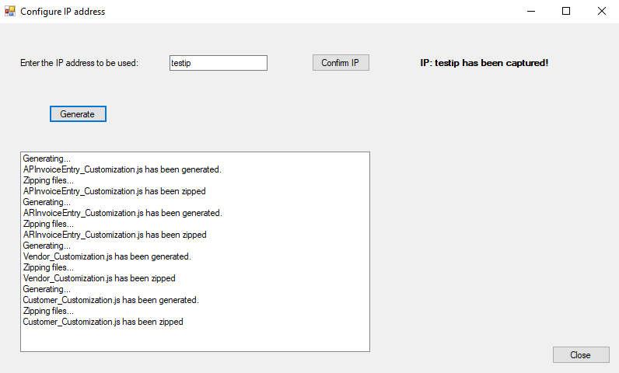

1. You will get feedback stating that the files have been generated and zipped.
2. You can close the GenerateFiles.exe application.

The folder on your desktop should look like this:

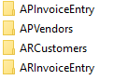

Inside each of these folders there should be a zipped file:

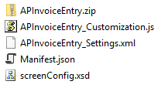

This means the files have been generated correctly.

## Upload files to Sage 300c

1. **Open** Google Chrome (or your supported browser) and type <http://localhost/Sage300/admin>
2. This will open the Sage 300 Admin site:

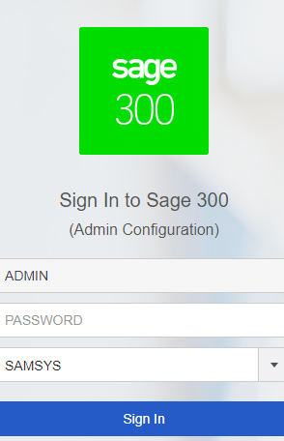

1. Log in to the website (the password is the same as for the normal admin in Sage 300).

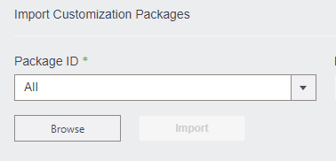

1. **Click** on browse and navigate to the desktop folder. **Click** on the zip file.

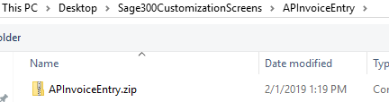

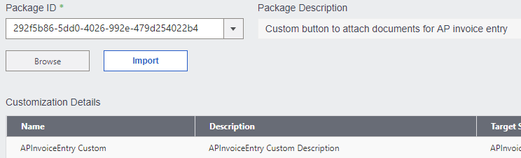

1. **Click** on Import.



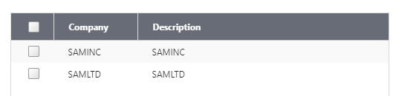

1. Click on Assign and assign the customization to your companies. Click ok.

The customization has been completed. Repeat step 4 – 6 for all the screens (APInvoice, ARInvoice, APVendors, ARCustomers).

1. Open your Chrome settings and clear your Cache:



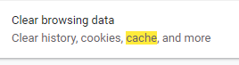

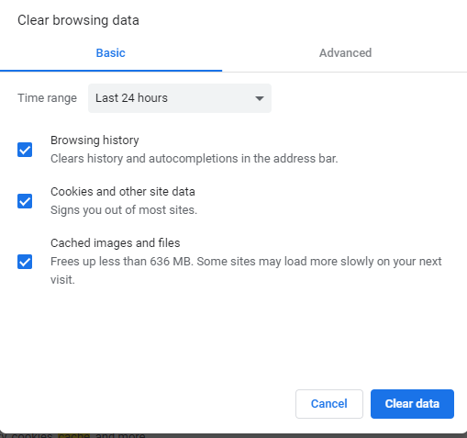

1. Log in to Sage 300c and the customization should appear on the selected screens.